Project Planning Phase

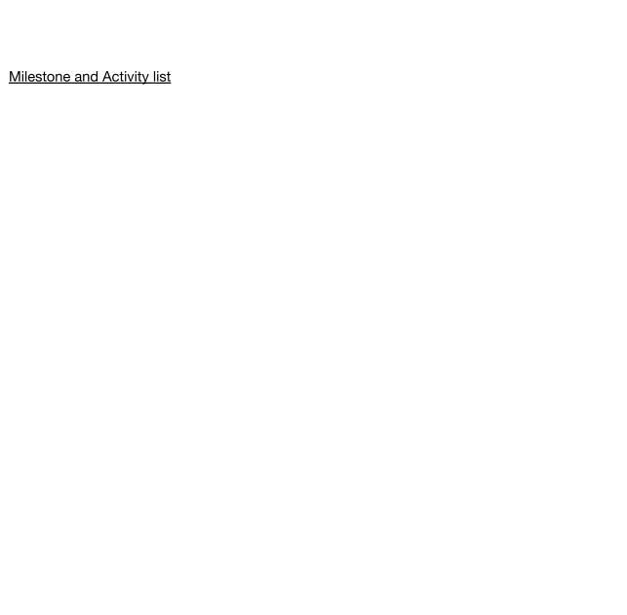Milestone and Activity list

|  |  |
| --- | --- |
| Date | 22 October 2022 |
| Team ID | PNT2022TMID04545 |
| Project Name | Plasma Donor Application |
| Marks | 4 Marks |

|  |  |  |  |  |  |  |
| --- | --- | --- | --- | --- | --- | --- |
| **Sprint** | **Functional Requirement (Epic)** | **User Story Number** | **User Story / Task** | **Story Points** | **Priority** | **Team Members** |
| Sprint-1 | Registration and Login | USN-1 | * To create the user and admin login functionality. | 20 | High | Dharanidharan K,Adithya B |
|  |  |  | * Creating plasma request by admin functionality |  |  |  |
| Sprint-2 | Cloud and database | USN-2 | * Connecting ﬂask app with database[IBMDB2] * implementation of chatbot. | 20 | High | Aravinth, Aananthakumar |
| Sprint-3 | Deploym ent in DevOps, Mailing | USN-3 | Creating images with docker,  deploying Kubernetes and Add the mailing service. | 20 | High | Dharanidharan,  Aananthakumar |
| Sprint-4 | Testing and Deployment to user | USN-4 | To make sure that the software is handy to users. | 20 | High | Adithya, Aravinth |